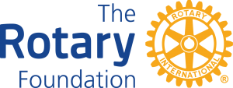

November 2024

Dear Friend,

Every Rotarian has a personal reason for joining. The thing we have in common is our strong commitment to making a difference. We are generous with our ideas, our energy, and our contributions to community causes. Whether large or small, each project we undertake is meaningful and important.
Consider what your 2023 gift can do!
- $25 can protect 40 vulnerable children from polio.
- $50 can provide clean water to help fight waterborne illnesses.
- $500 can launch an antibullying campaign and create a safe environment for children.

You leverage and amplify your individual impact by joining with other Rotarians to support “Every Rotarian Every Year” – the Annual Campaign. Directing your gift to one of these featured causes counts for Paul Harris Fellow recognition.

- Annual Fund – SHARE
- Polio Plus Fund
- Disaster Response Fund
- Endowment-Share
- Miles to End Polio
- World Fund

For even more information visit: https://my.rotary.org/en/document/every-rotarian-every-year-brochure or https://my.rotary.org/en/document/rotary-foundation-facts-print

Your gift to the Rotary International Foundation gives you a meaningful opportunity to join with Rotarians throughout the world to be a part of making these – and other positive changes. Your gift of $100, or more is especially helpful. Please make your generous gift today!
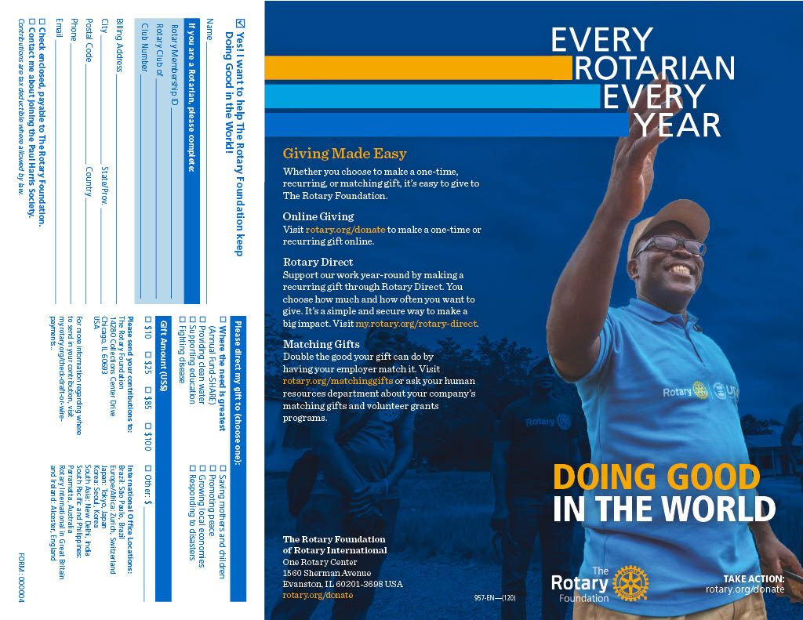
Yours in Rotary Service,

Name
Your Club Name

It’s Easy!
- Make your gift online visit: https://my.rotary.org/en/donate
- Mail your gift with the coupon below: Rotary Foundation 14280 Collections Center Drive Chicago, IL 60693

