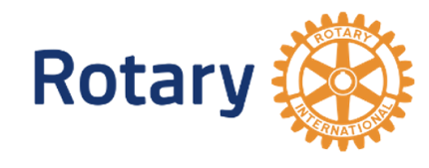
Roger Taylor
Rotary Speech Contest
Grand Prize $1000
(with cash awards for 2nd & 3rd place)
Write and deliver a 5-7 minute original speech that addresses an ethical issue of your choosing using the principles of Rotary’s Four-Way Test*.

WHO: Students Grades 9-12. No affiliation with Rotary or Interact is necessary.

WHY: Win $1000! Looks great on Resume! Enhance your public speaking and
critical thinking skills!

WHEN:
&
WHERE:

The winner of the Finals will be awarded $1000
(Additional cash awards for 2nd & 3rd place, as well as semi-final cash awards)

For more details, email rsc7450@gmail.com
or contact your local Rotary Club

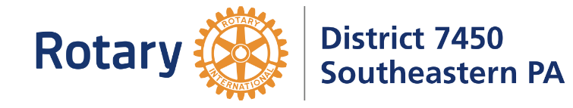
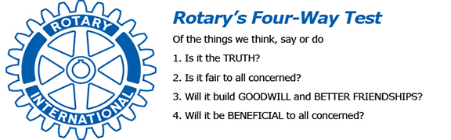
Sponsored by
*
- The first round to be held BY March 4, 2023 (Exact date and virtual or in person is at the discretion of your local Rotary Club)
- Semi-Finals April 1, 2023 at a venue TBD – there will be 3 regional locations around Philadelphia
- Finals April 16, 2023 at a venue TBD (likely in King of Prussia area)

