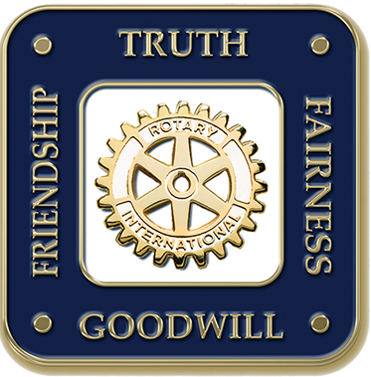

The Four-Way Test

The Four Way Test is, put simply, a yardstick code of ethics that helps us to be better Rotarians, better citizens and better friends. Since it’s adoption, the test has been translated into over 100 languages and is used around the world as guiding set of principles.

Imagine a world where everyone used this set of principles to guide their actions.

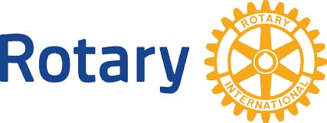

District 7450 contact information

DGN Roger Taylor 484-889-1455 - [rogertaylor.rotary@gmail.com](mailto:rogertaylor.rotary@gmail.com)

- or -

AG Chris Potter 215-601-7433 insurancepotter@msn.com

2019-2020

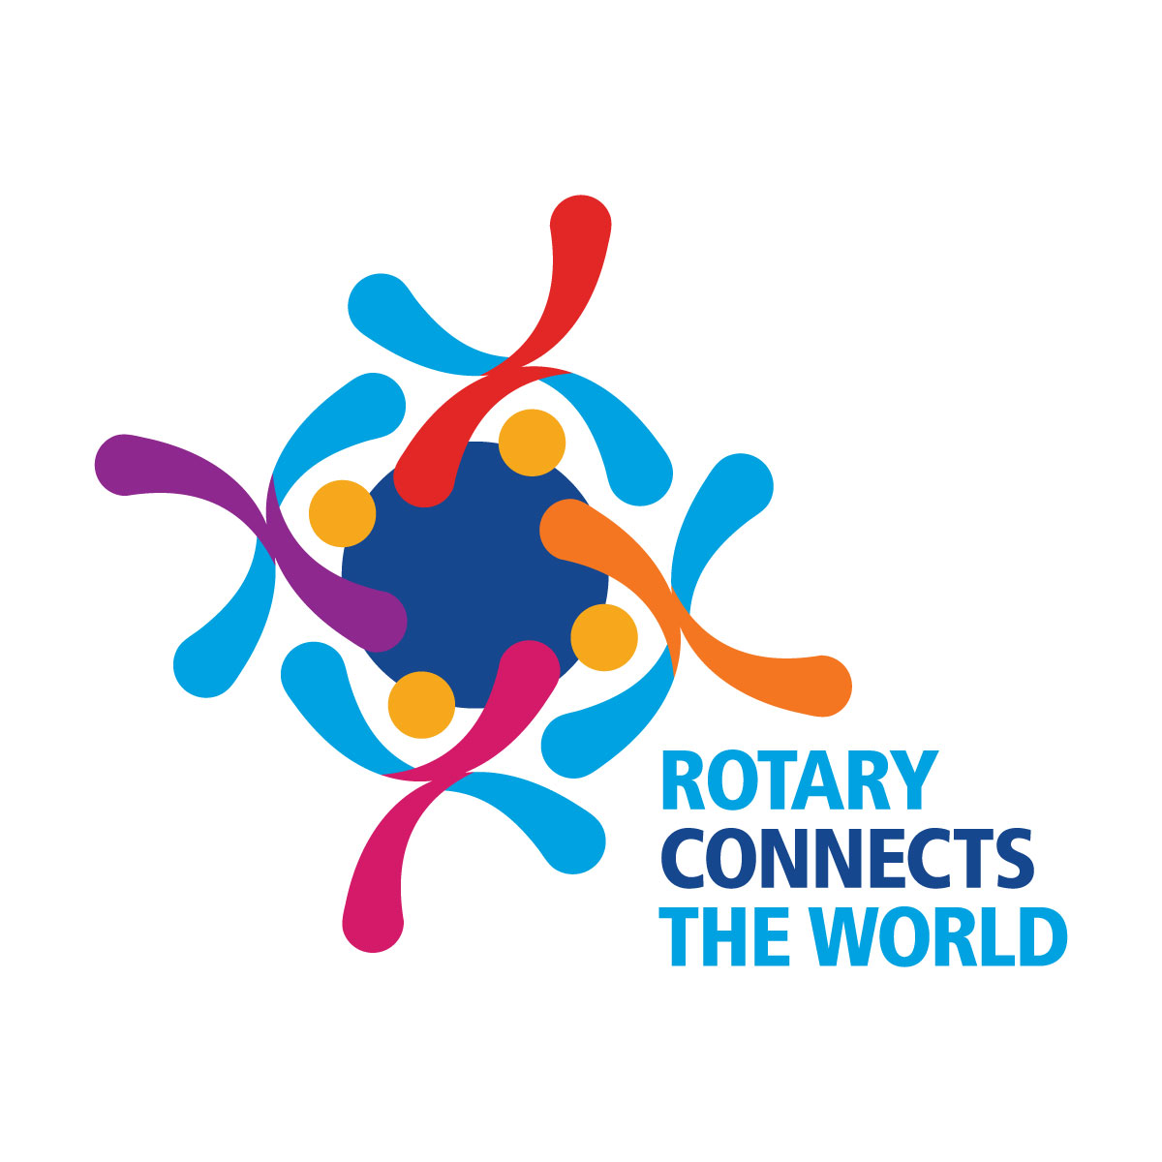

Rotary Four-Way Test

Speech Contest

*Ethics for the Modern World*

Participants must be 9th through 12th grade high school students.

Contestants will write/develop a speech on any subject and apply the “Four-Way Test” throughout. The speech must be between 5 and 7 minutes long.

Preliminary contests will be held locally.

Semi-final Competitions will be April 18th, 2020 at a venue to be determined. Registration Fee $75

Winners of the Semi-final competition will compete in the Finals at a Rotary District Conference at the Elmwood Park Zoo

1661 Harding Blvd, Norristown, PA 19401 on the 16th of May 2020

The Grand Prize for the winning speech will be:

$1000

How it Works

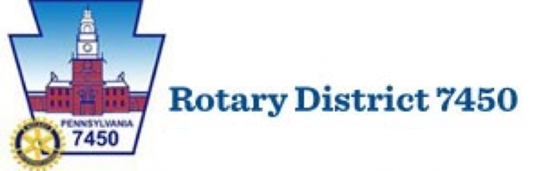Version 4.0