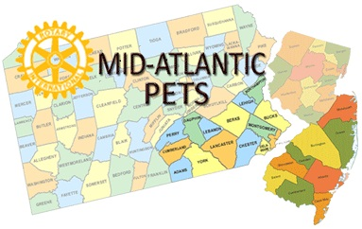 Mid-Atlantic 
President-elect Training Seminar

MANUAL



Radisson Valley Forge Casino Resort
February 26 – 28, 2015
www.mapets.org

